USE CASE: Add task

**Conditions**

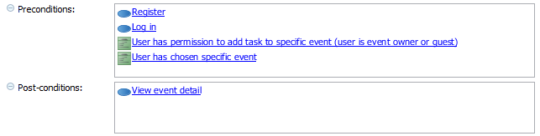

**Flow of events**

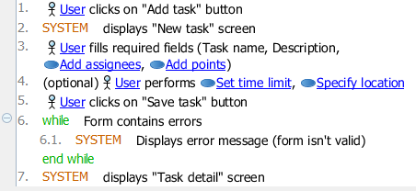

USE CASE: Create event

**Conditions**

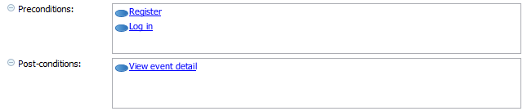

**Flow of events**

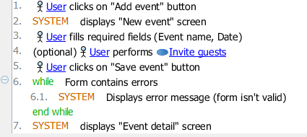

USE CASE: Generate event summary

**Conditions**

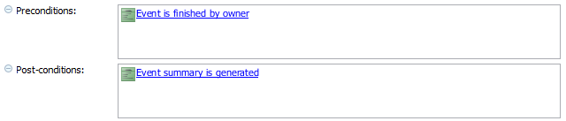

**Flow of events**

